ASSIGNMENT 3 DATA 1203

EXECUTIVE DASHBOARD

REPORT

MEMBERS: RIVAN JOSE(100992168)

DEBOPRIYA DATTA (100997901)

DRASHTI MAKWANA (100995859)

PROFESSOR: REJOY JAMES

**Executive Summary**

This report provides valuable observations on the inventory, sales, and profitability performance of The Coffee Cup in 2019 from cleaned and organized data in different Canadian markets. The use of a Tableau executive dashboard facilitated the analysis by providing good visualization of product-level sales trends, regional profitability, and adherence to budget over months

1. **Data Quality Assessment**

**Overall Quality:** Adequate, with specific areas requiring improvements for advanced analysis.

**Key Observations:**

The dataset had three duplicate entries. All of the important fields—Province, Product Type, Month, Market, Sales, Budget, Profit, Margin, and Inventory—had these precise matches, suggesting that there were probably data input mistakes.

* **Duplicate Records:**
  + Duplicates Removed:
    1. Nova Scotia | Espresso | June | Atlantic | 1600 | 1500 | 1100 | 68.75 | 80
    2. British Columbia | Coffee | March | Pacific | 2000 | 2100 | 1250 | 62.50 | 95
    3. Quebec | Tea | December | Central | 800 | 1000 | 350 | 43.75 | 60
* **Missing Values:** Nothing. The dataset was complete with all fields filled.
* **Data Consistency:**
  + Uniform use of month names and product types.
  + While most market and province pairings were accurate, a few entries needed cross-checking to guarantee geographic coherence.
* **Format Uniformity:**

Sales, profit, inventory, and other numerical fields were formatted correctly for analysis.

Categorical entries have to be slightly standardized (uniform capitalization, for example).

**Cleansing Performed:**

* Removed 3 duplicate rows to prevent inflated results.
* Standardized categorical labels for better readability.
* Reviewed market-province mapping to ensure logical consistency.

**2. Questions the Dataset Effectively Answers**

1. Which market performed best in profit?

Insight: The West market performed best in terms of profit, with strong figures in British Columbia and Alberta.

2. Which provinces made the largest contribution to overall profit?

Insight: British Columbia and Quebec were high performers in profit.

3. Are sales ahead of or behind the budget by month?

Insight: Sales outperformed budgets across the board, especially in high months like May and August.

4. What are the top-performing product types in terms of sales?

*Insight:* Espresso and Coffee have a better performance as compared to others; Tea had a fewer contribution.

1. **Questions the Dataset Does Not Answer (But Should)**

1. Customer Preferences and Behaviors:  
a. Which customer segments prefer which product types?  
b. What is the demographic profile of our repeat customers?

2. Operational Efficiency:  
a. How long do inventory sit on the shelf (turnover ratio)?  
b. What is the average lead time to replenish inventory?

3. Marketing Effectiveness:  
a. What is the ROI per individual campaign?  
b. How do marketing efforts relate to sales spikes?

4. Sales Channel Analysis:  
a. What is the proportion of online sales versus retail stores?  
b. How do trends by province vary by channel?

1. **How does inventory align with margin performance by product type?**  
   *Insight:* Espresso and Coffee had both high margins and inventory, pointing to efficient demand planning.

**4. Data Gaps and 2020 Data Collection Recommendations**

To support deeper analysis and executive decision-making, the following data should be captured in 2020:

|  |  |  |  |  |  |  |  |  |  |  |  |  |  |  |
| --- | --- | --- | --- | --- | --- | --- | --- | --- | --- | --- | --- | --- | --- | --- |
| | **Additional Data Required** | **Purpose** | | --- | --- | | Customer Demographics | Enables segmentation, targeted promotions, and loyalty analysis | | Sales Channel (Retail vs Online) | Understand distribution effectiveness and optimize resources | | Promotional Campaign Details | Analyze sales lift due to campaigns; measure ROI | | Inventory Replenishment Data | Measure supply chain responsiveness and avoid stockouts | | Customer Feedback and Ratings | Gauge satisfaction, identify improvement areas | | Transactional Timestamps (Day/Time) | Analyze micro-trends and improve store scheduling | |

**5. Executive Dashboard Design & Interpretation Guide**

The dashboard built using Tableau includes visualizations aligned with our strategy map, allowing executives to monitor key performance indicators effectively.

**Dashboard Components:**

**1. Profit by Market/Province (Bubble Chart):**

* Size represents profit size.
* Darker, larger bubbles represent top-performing regions.

Action: Focus marketing and inventory efforts in these provinces.

**2. Monthly Sales vs Budget (Line Graph):**

* Two lines trace actual vs. budgeted sales.
* Trend analysis facilitates forecasting and financial planning.
* Action: Take note of underperforming months and analyze reasons.

**3. Sales Distribution by Product Type (Treemap):**

* Color and size intensity reflect product performance.
* Espresso is predominant with potential bundling or upselling opportunity.

**4. Margin vs Inventory (Bar Chart):**

* Links profitability to levels of inventory.
* Action: Use this to reassess stock levels for low-margin items.

**Usage Tips:**

•Apply filters (by Province, Market, Product Type) to get targeted insights.

• Look for mismatches (e.g., high inventory with low margin) for opportunities to optimize.

• Use visuals to inform quarterly and yearly strategy changes.

**6. Final Strategic Recommendations**

The Coffee Cup dataset for 2019 offers valuable insights into financial performance and inventory trends. However, the current data lacks granularity in customer behavior, marketing impact, and operational efficiency—critical pillars for a competitive edge.

**Recommended Actions:**

• Increase the scope of data collection to encompass marketing, customer, and transactional aspects.   
• Apply validation rules at data entry sites and keep an eye on a master data quality log.  
• To find and get rid of future irregularities (like duplication), set up routine data audits.   
  
Coffee Cup may transition from reactive reporting to proactive, predictive analytics that drive strategic growth by putting these suggestions into practice and incorporating improved data in 2020.

**Dashboard Visuals:**

1. Profit by Market/Province (Bubble Chart)
2. Monthly Sales vs Budget (Line Graph)
3. Sales Distribution by Product Type (Treemap)
4. Margin vs Inventory (Bar Chart)

The Executive Dashboard for the 2019 data with instructions on how to interpret the dashboard.

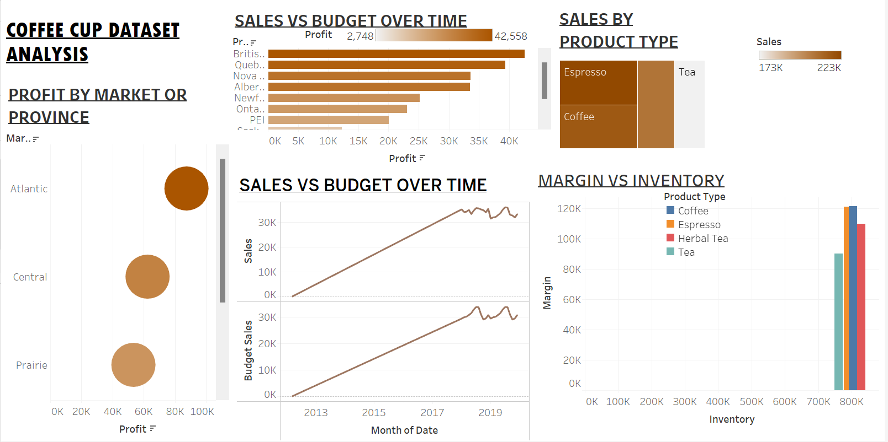

**Conclusion**

The Coffee Cup's 2019 data provides insightful information about inventory alignment, product performance, and regional profitability. The company is in a good position to take advantage of these advantages because Espresso and Coffee have the highest sales and profit margins, and the West market is doing better than the others.

The Coffee Cup can go from reactive reporting to strategic foresight by improving data quality, expanding its data landscape, and utilizing visual analytics more thoroughly. This will enable more intelligent operations, improved consumer interaction, and increased profitability across Canada.